**A**

**MINI PROJECT REPORT**

**ON**

**“EXPENSE TRACKER”**

**OF**

**MASTER OF COMPUTER APPLICATIONS (MCA)**

**SUBMITTED BY**

**SAKSHI HIRALAL PARDESHI**

**UNDER THE GUIDANCE OF**

**prof. Rani jadhav**

**TO**

**SAVITRIBAI PHULE PUNE UNIVERSITY**

**DR. D.Y. PATIL CENTRE FOR MANAGEMENT & RESEARCH,**

**CHIKHALI, PUNE-411062**

**2022-2023**

**CERTIFICATE**

This is to certify that Mr. /Ms **SAKSHI HIRALAL PARDESHI** is student of MCA 1st Year full time degree course at our Institute. His/ Her MINI PROJECT WORK TITLED **"EXPENSE TRACKER"** submitted as part of the curriculum for the award of Master of Computer Application degree of Savitribai Phule Pune University, Pune. This is an original work done by him / her. This work is not submitted earlier in part or full to this or any other institute / University for any degree / diploma.

**Project Guide HOD Director**

**DYPCMR DYPCMR DYPCMR**

Place:

Date:

**ACKNOWLEDGEMENT**

My sincere thanks to our Director Sir Dr. Sunil Dhanawade and HOD Prof. Minal Pawar without whose guidance, ideas and time to time help to this project would not have been completed. I would have never got this exhilarating sense of accomplishment without his guidance. Especially I thank my project guide Prof. Rani Jadhav faculty of S. M. Dr. D. Y. Patil Centre for Management and Research, Chikhali, Pune for her valuable guidance, co-operation & encouragement throughout the project.

Date: Signature

Place: (Sakshi H.Pardeshi)

**INDEX**

|  |  |  |  |
| --- | --- | --- | --- |
| **Chapter No.** | **Particulars** | | **Page No** |
| **I** | **Introduction** | |  |
| **1.1** | **Problem Statement** |  |
| **1.2** | **Purpose, Objective and goals** |  |
| **1.3** | **Literature Survey** |  |
| **1.4** | **Project scope & limitations** |  |
| **1.5** | **Existing System** |  |
| **1.6** | **Scope and limitations of existing systems** |  |
| **II** | **Requirement Analysis** | |  |
| **2.1** | **Functional requirements** |  |
| **2.2** | **Performance requirements** |  |
| **III** | **System Analysis** | |  |
| **3.1** | **ER Diagram** |  |
| **3.2** | **UML Diagrams** |  |
| **IV** | **System Design** | |  |
| **4.1** | **Data Dictionary** |  |
| **4.2** | **User Interface(Input & Output Screen)** |  |
| **V** | **Report Testing** | |  |
| **VI** | **Limitations and Conclusion** | |  |
| **VII** | **Bibliography** | |  |

**1. INTRODUCTION**

**1.1 PROBLEM STATEMENT**

If you’ve tried budgeting and failed miserably, using an **expense tracker** can **solve your budget planning problems**. Expense tracking isn't just about saving all of your receipts or writing down every cent you spend for the rest of eternity. It’s actually much simpler than that.

[**Tracking expenses**](https://www.mymoneycoach.ca/resources/financial-worksheets/expense-tracker-worksheet-calculator)is the difference between creating a budget that works, and one that doesn’t. Whether you’re about to start budgeting for the first time, or have been living on a budget for years, knowing where your money goes is the one thing that is guaranteed to make your budget work.

**1.2 PURPOSE, OBJECTIVE AND GOALS**

PURPOSE

* You Better Control Your Cash Flow.
* You Spend More Responsibly to Stay Within Budget.
* You’re Better Prepared for the Tax Season and May Get Money Back.
* You Can Quickly Determine How Profitable Your Business Is.
* You Keep Your Employees Happy.

OBJECTIVES

Our goal is to create an expense tracking system where user can be tracking all financial

activities and view previous income and expense report.

❖Users can easily review the reports daily, weekly, monthly or yearly.

❖Users can update or delete records.

❖Users can get notifications daily. Create Category and Change currency.

❖Users can also change Notification time and modify some features.

❖Add Expense and Income.

GOALS

* To manage proper data
* To manage documents
* Provides accurate analysis
* Prevents Human Error
* Generates reports

**1.3 LITERATURE SURVEY**

We found various similar product that have already been developed in the market. Unlike all those products Personal Expense Tracker (PET) provides security and graphical results. We provide the users to enter their wish-list before any purchase.

**1.4 PROJECT SCOPE AND LIMITATIONS**

It will have various options to keep record (for example Food, Travelling, Entertainment etc.).

Automatically it will keep on sending notification for our daily expenditure.

In today’s busy and expensive life, we are in a great rush to make moneys, but at the end of the month we broke off. As we are unknowingly spending money on title and unwanted things. So, we have come over with the plan to follow our profit.

Here user can define their own categories for expense type like food, clothing, rent and bills where they have to enter the money that has been spend and likewise can add some data in extra data to indicate the expense.

**1.5 EXISTING SYSTEM**

Earlier in the system, if someone wanted to estimate his expenditure, he used to keep a manual in writing so that it was not possible to estimate how much and where the expenditure was going. If the paper is lost somewhere, the record which is written on it will also be lost. In all this process require a lot of time. Person cannot keep track of his records rapidly in the manual system there are the chances of lost of paper or lost of record keeping book the chances of getting lost of those record track are very high. Sometimes due to lack of time and person cannot daily record or write all his expenses on the paper.

**1.6 SCOPE AND LIMITATIONS OF EXISTING SYSTEM**

System needs much more time and efforts to track all the records. When your manual data is in proper manner you can expect of record is safe all this process require a lot of time. Person cannot keep track of his records rapidly in the manual system there are the chances of lost of paper or lost of record keeping book the chances of getting lost of those record track are very high. Sometimes due to lack of time and person cannot daily record or write all his expenses on the paper.

**2.REQUIREMENT ANALYSIS**

**Functionality of modules**

User Management of Module:

User Registration:- Allows new users to create an account to access the expense Tracker

User login:- Provides Registered User to securely log into their accounts.

Profile

User can view their own information and edit .

Expenses Recording Module:-

Add Expenses:- Enable user to record their expenses by entering details such as amodate , category.

Edit Expenses:- Allows users to modify or update existing expenses entries.

Delete Expenses:- Provide the Functionality to remove expenses records from the system

Records:

weekly Records:- User can view their weekly Expenses with pie chart

Monthly Records:- User can view their Monthly Expenses with pie chart

Yearly record:

User can view yearly record according to his expenses

History:

User can view his data in the table format

Logout

## Technical Architecture: -

It is a web application developed using Python and Django framework and sqlite database

**Hardware & Software Requirements**

**At Server Side**

**Hardware Configuration**

|  |  |
| --- | --- |
| **Name** | **Details** |
| Processor | I3 or more |
| RAM | 8 GB or more |
| Hard Drive | 1 TB or more |

**Software Environment**

|  |  |
| --- | --- |
| **Name** | **Details** |
| Operating System | Windows 11 |
| Database Sever | SQlite |
| Application Server | python |
| Browser | Chrome, Edge, Mozilla |
| Framework | Django |

**At Client Side**

**Hardware Configuration**

|  |  |
| --- | --- |
| **Name** | **Details** |
| Processor | I3or more |
| RAM | 8 GB or more |
| Hard Drive | 1 TB or more |

**Software Environment**

|  |  |
| --- | --- |
| **Name** | **Details** |
| Operating System | Windows 10 |
| Browser | Chrome, Edge, Mozilla |
| Framework | django |

**3.SYSTEM ANALYSIS**

**USE CASE**

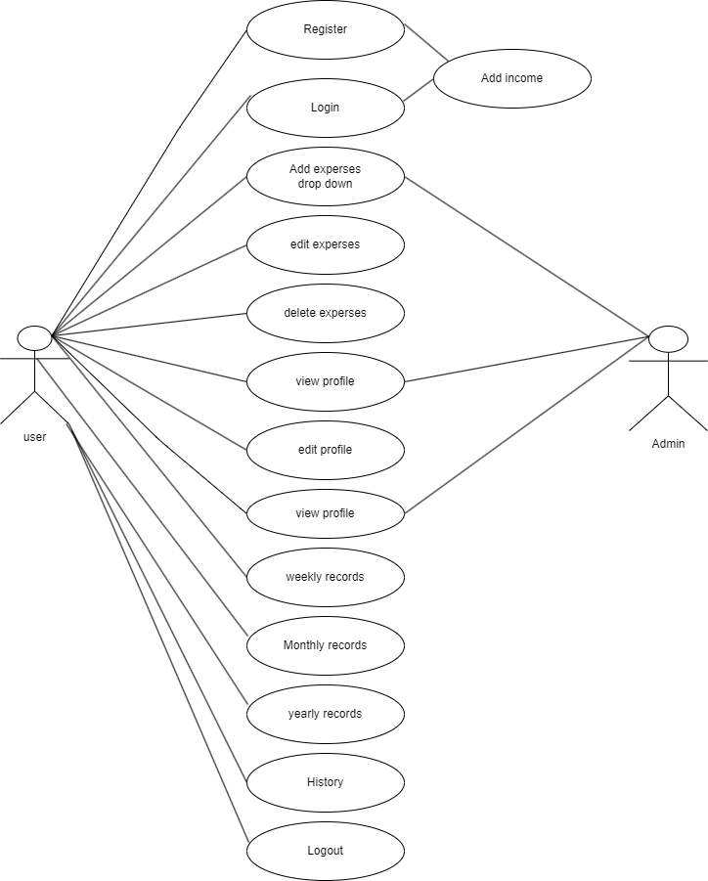



**ACTIVITY**

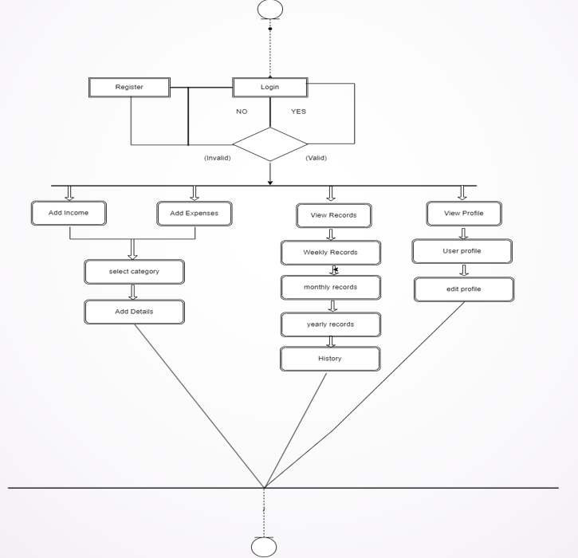

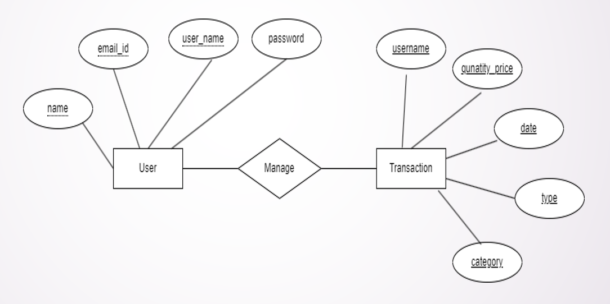

SEQUENCE

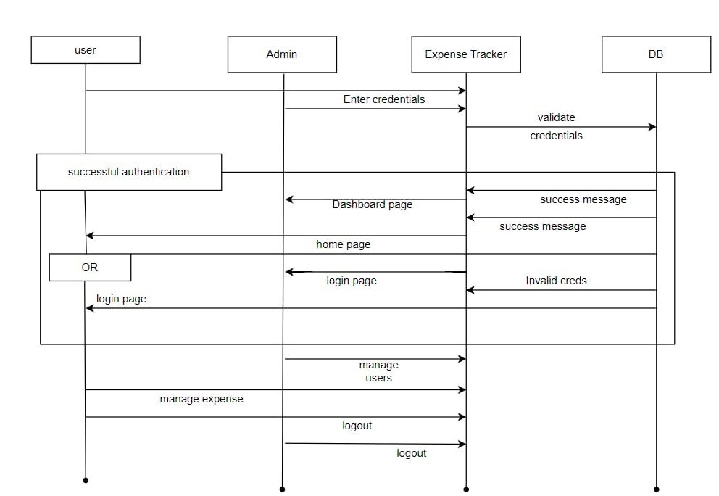



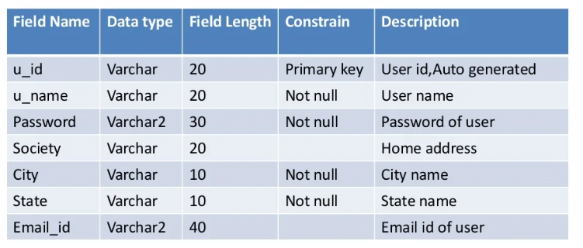**SCREEN**

**REGISTRATION SCREEN**

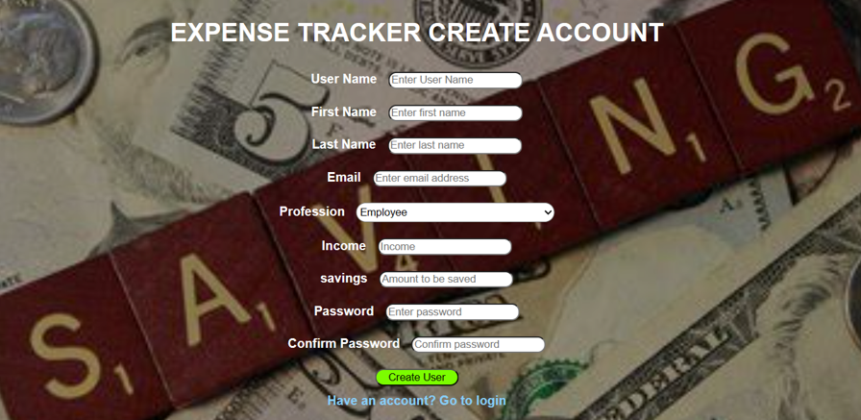

**LOGIN SCREEN**

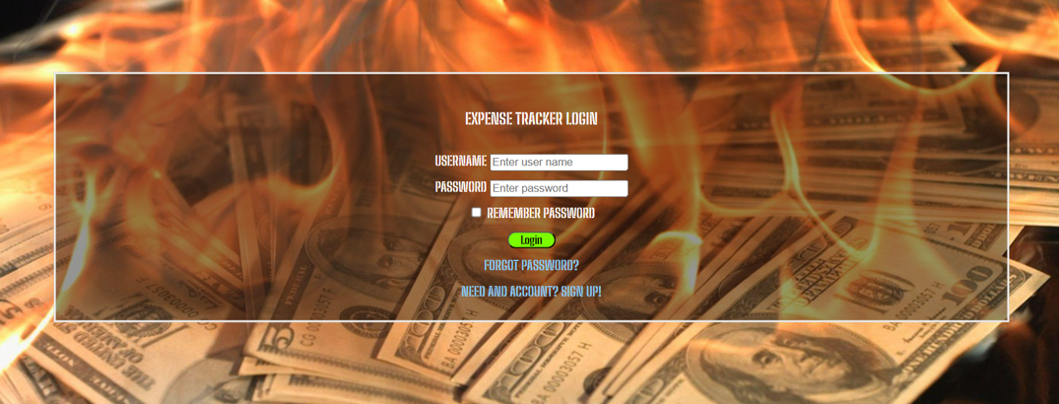

**DASHBOARD**

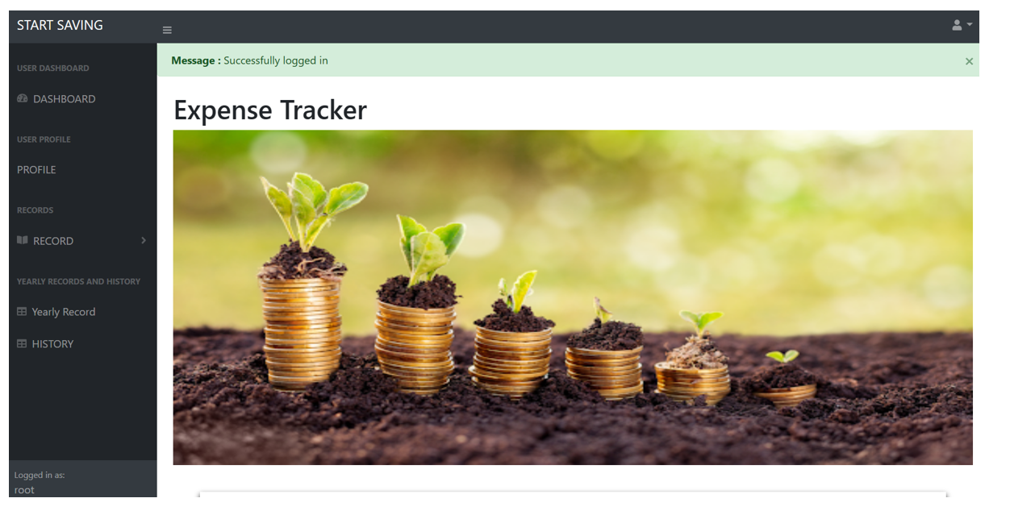

**MY WALLET**



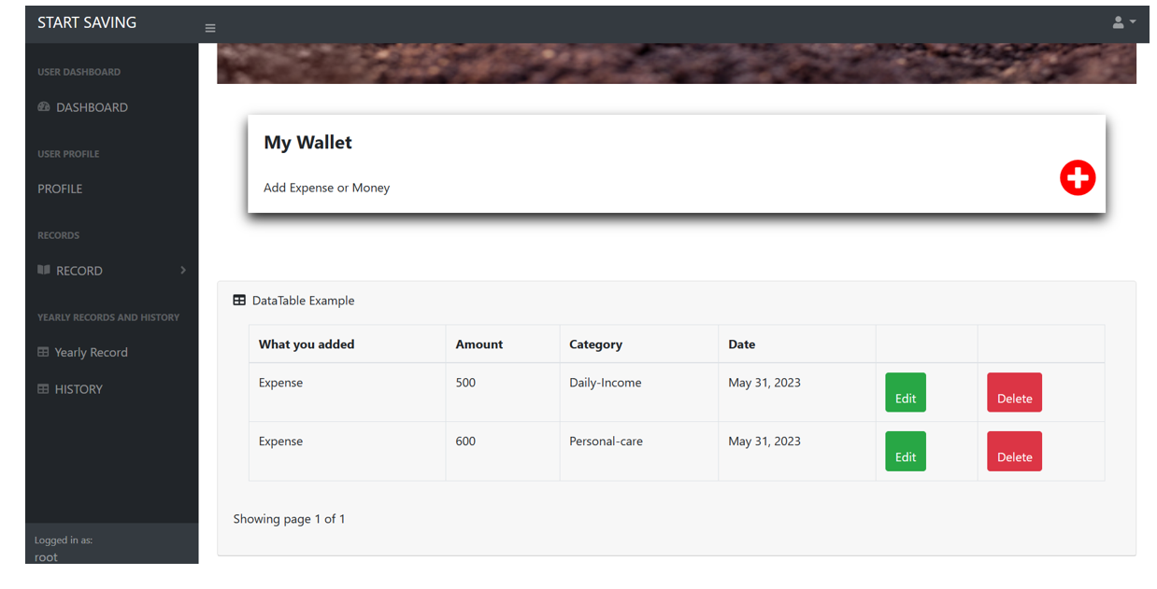

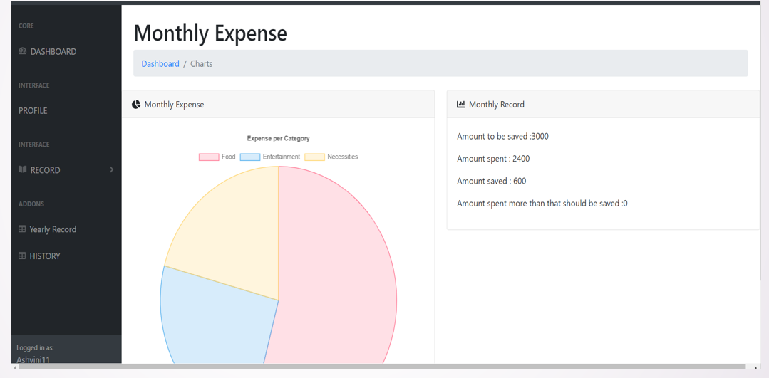

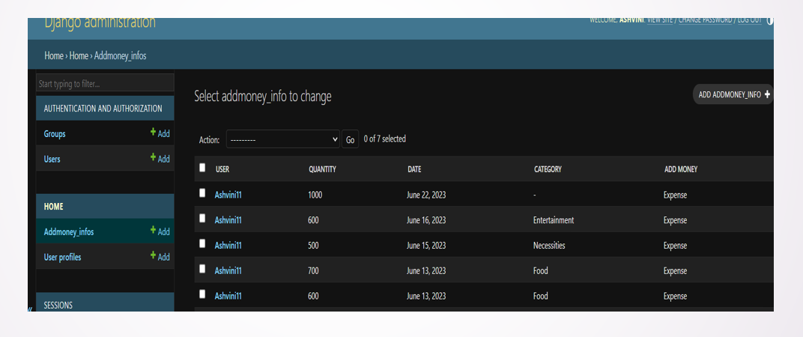

**Limitations and Conclusion**

If you’ve tried budgeting and failed miserably, using an **expense tracker** can **solve your budget planning problems**. Expense tracking isn't just about saving all of your receipts or writing down every cent you spend for the rest of eternity. It’s actually much simpler than that.[**Tracking expenses**](https://www.mymoneycoach.ca/resources/financial-worksheets/expense-tracker-worksheet-calculator)is the difference between creating a budget that works, and one that doesn’t. Whether you’re about to start budgeting for the first time, or have been living on a budget for years, knowing where your money goes is the one thing that is guaranteed to make your budget work.

**Bibliography**

Websites :

• https://www.google.com

• https://www.youtube.com